**Problem 2 – R Code**

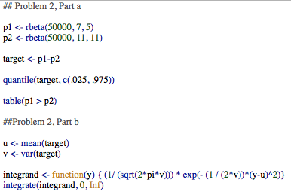

**Problem 3**

**Part a**

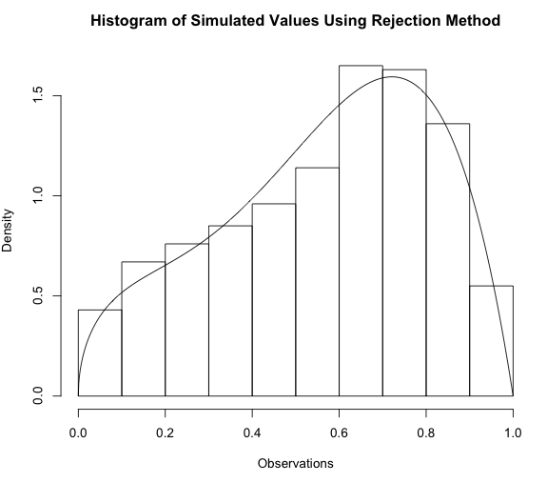

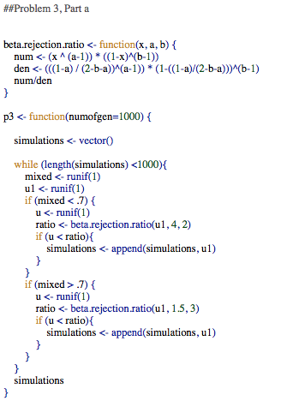

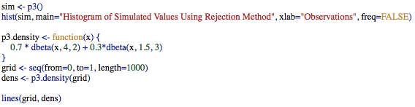

**Part b**

The MH Acceptance rate is 77.2% when I run my function. The plot of the simulated chain from the Metropolis-Hastings Algorithm is given below. I used a Beta(1, 1) distribution for the candidate distribution.

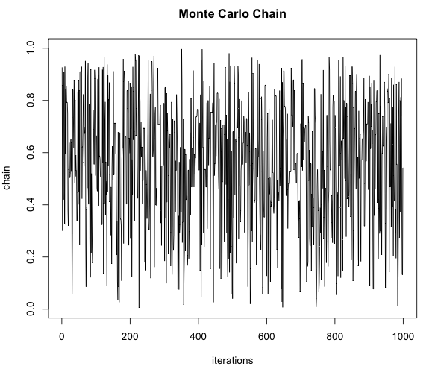

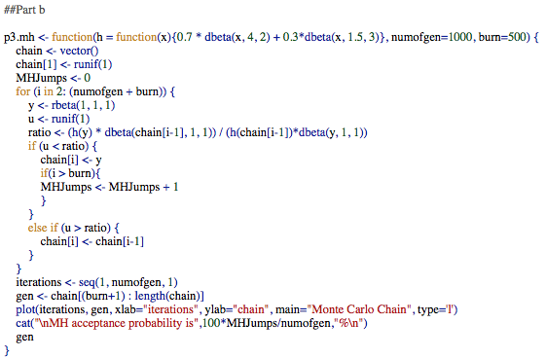

**Part c**

I chose a standard deviation of 2 for the random walk. This produced results in line with the simulated values in part a. The acceptance rate for my function was 76.5% when I ran it.

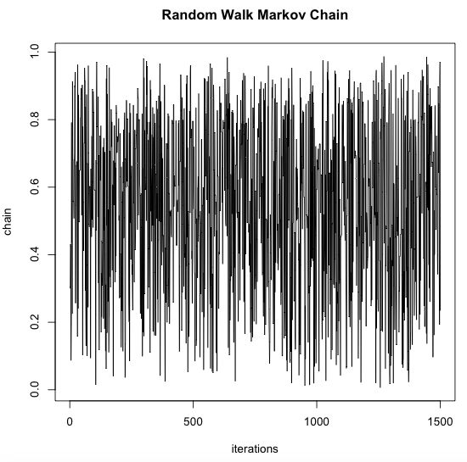

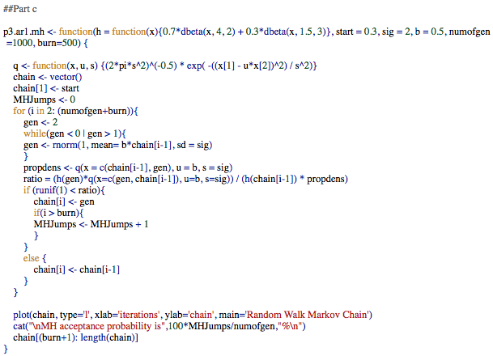

**Problem 4**

**Part a – See notebook paper.**

**Part b**

The code and plots are given on the following pages. Based on the plot, I do not think the algorithm has converged. There are periods of convergence but then the variability increases dramatically at times.

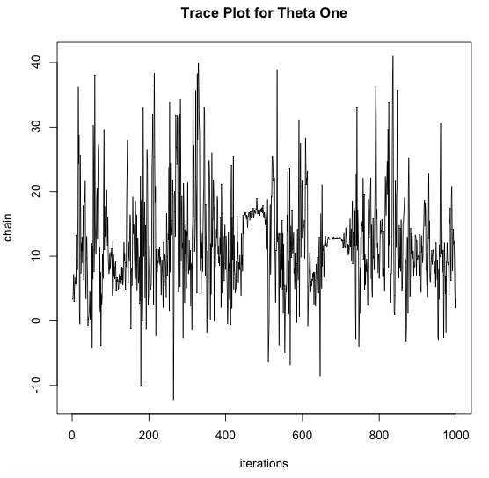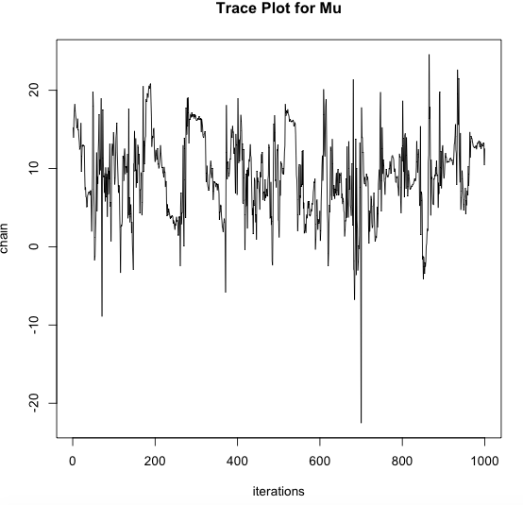

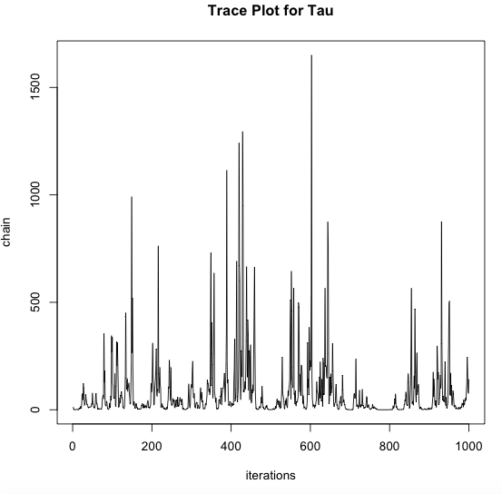

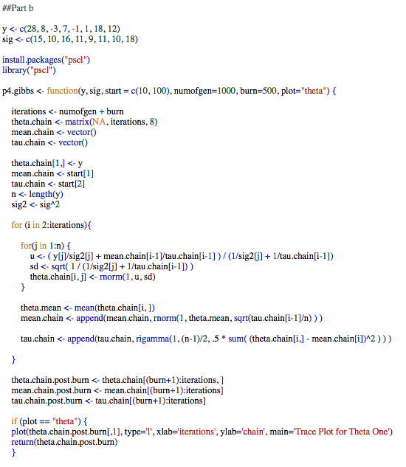

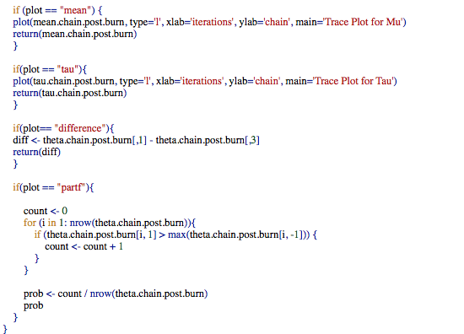

**Part c**

An estimated 95% credible interval for mu is [-1.977395, 17.494533]. Based on this credible set, which includes zero, I do not believe that SAT preparation courses are generally helpful. Please see plot and code below.

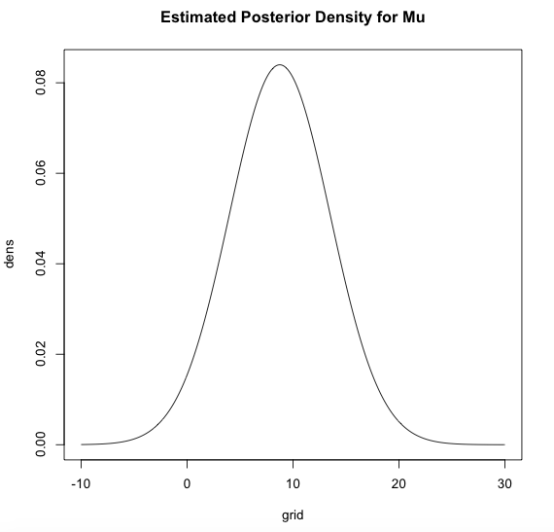

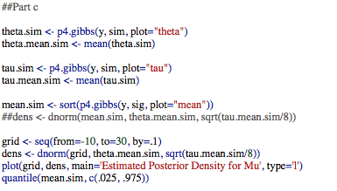

**Part d**

The 95% posterior credible interval is [26.89888, 29.01522], which is based on simulated values of theta 1. The estimated posterior density plot given below is based on average values of mu and tau, which produces an estimate that is different than the 95% posterior credible interval given above.

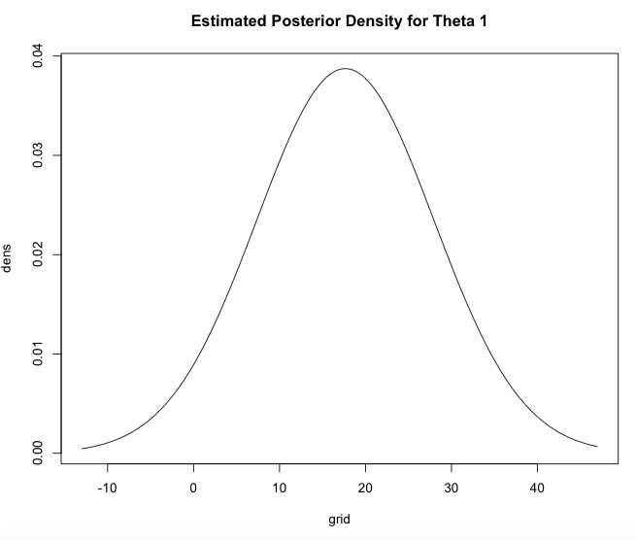

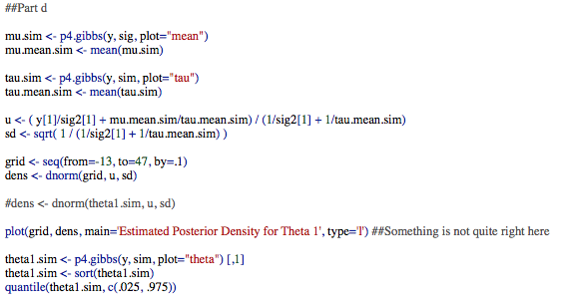

**Plot e**

See code for function in Part b for specifics of how difference is calculated. The 95% credible interval for the difference between theta 3 and theta 1 is [-11.09871, 36.6658]. Therefore, we conclude that there is no difference between the two schools.

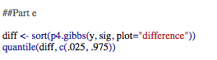

**Part f**

See code for function in Part b for specifics of part f calculation. The simulated posterior probability is 24.9% for when theta1 is greater than the max of theta 2 through theta 8.

